Standard GX-5850T 902-928 MHz Ham Conversion Notes

Disclaimer
I do not claim to be an expert; modifying radio programming data may have adverse effects on your equipment. The following is my work into converting the Standard GX-5850T for use on the 902 – 928 MHz Ham band, and should be used with caution.

Programming Software

The first step is to get familiar with the programming software interface. Take some time and look around to see what options are available. This is the “Common Data” entry page. This area has all of your Scan and Interconnect options.

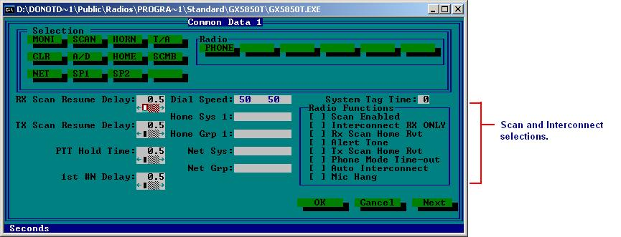

One of the nice things about these radios, is their conventional operation. Under the “Edit System Data” tab, we find that there are 3 options:
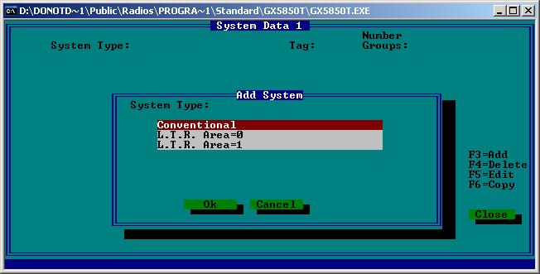

I have been using the Conventional entry for the conversion. Once you select conventional, you will see this screen. I have already entered the “Tags” to denote the START and END of the channel data, and the FCC Chan. Number.

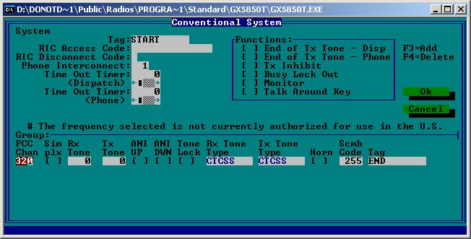

I like to use FCC channel 320 because it is a base line to convert from, since it is equal to 900.00 MHz TX and 939.00 MHz RX.

Here is how the channel data is stored:

RX frequency data comes first in the line. I found this by simple trial and error.
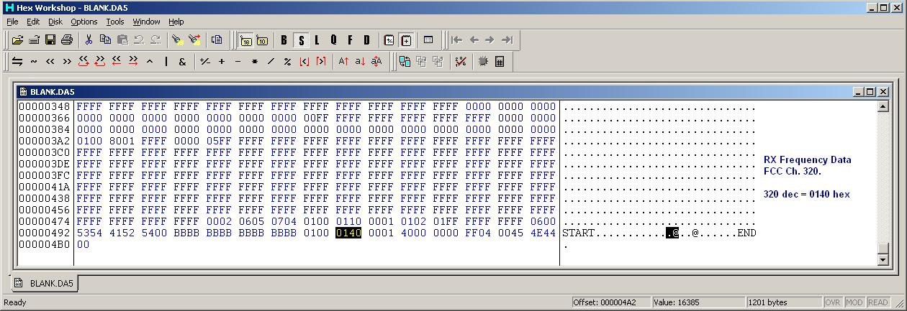

Next comes the RX PL/DPL Data. This example has no pl or dpl entered.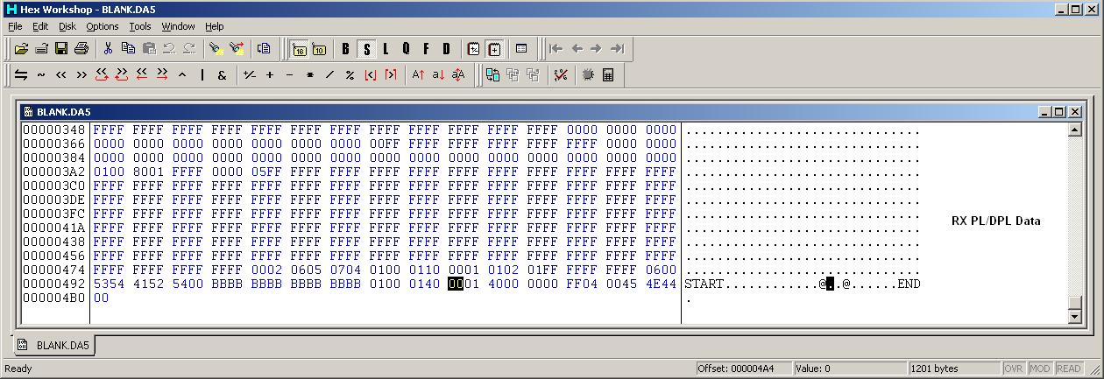

Next is the TX Frequency Data, in a standard Conventional system. Simplex Systems will be different.
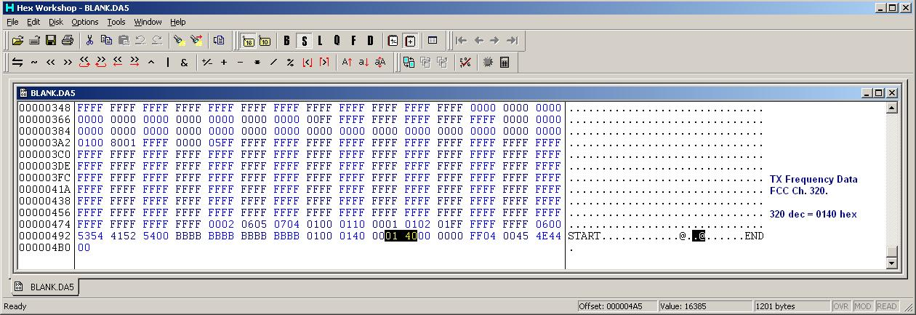

Then the TX Pl/DPL Data. This example has no pl or dpl entered.
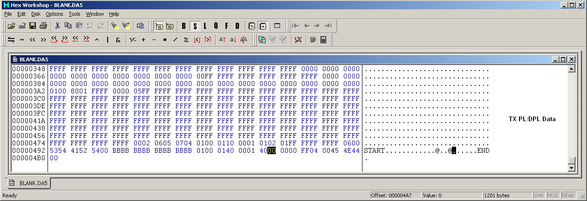

Conventional Simplex System

The channel data is entered in a different way here, the RX frequency stays the same as it would in a Standard Conventional System.
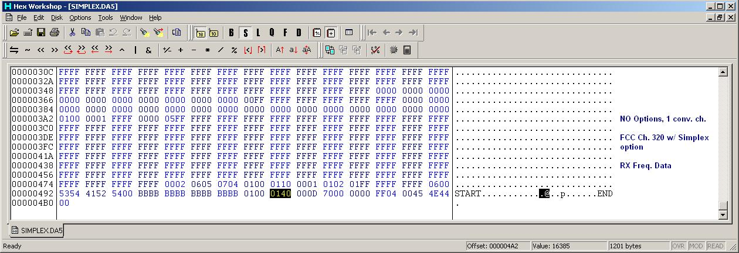

Now, the Simplex TX data. Using the simplex option, the TX frequency is raised to match the RX. This means that if you setup a simplex system, your RX freq. (on FCC #320) will be 939.000 MHz which we know is entered as “0140” in hex. To match the TX freq. you have to add 39 MHz worth of channels to the standard ch. 320. So if you have ch. 320 programmed as simplex your TX channel number will be ch. 3440, or “0D70” in hex.

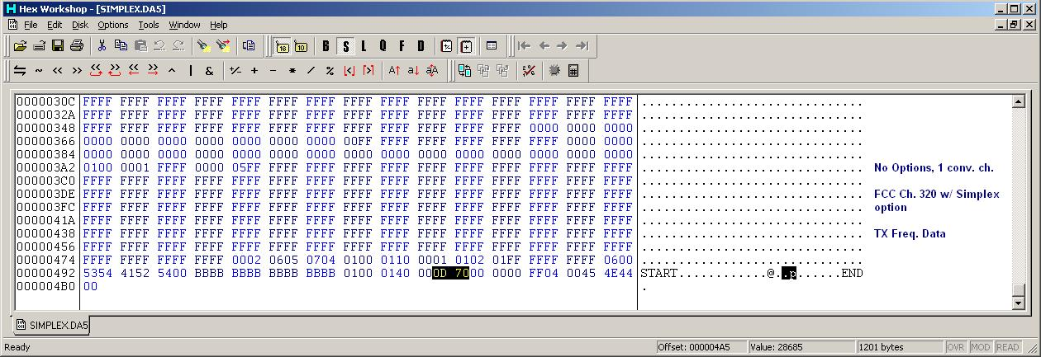

Ok, take a break, because if you’re anything like me, you’re ready to scream by now.

FCC Channel Numbers and spacing

Now that we know how the channels are entered in the data file, you’ll probably want to start converting. Hang on a second. You’ll need a couple of things to make this go as smooth as possible.

First you need a calculator, or brain, whichever you prefer to use.

Second thing is a base converter or hex converter so you can enter the data. Most Hex editing programs include one. I use Hex Workshop v4.2, it’s free and it has many useful features.

Using FCC channel numbers we can see that each channel is a 0.0125 MHz step. Every 80 channels you go up or down, you gain or loose 1 MHz. So if you wanted to set your TX frequency at 902 MHz, you would add 160 to the base 320 and get 480.

Use your hex converter and you’ll see that 480 equals “01E0” in hex.
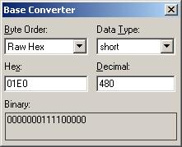

So that’s the TX data, simple. Convert it, enter it, save it, save it again just to be sure.

***UPDATED*** The RX side is a lost cause. Due to VCO issues, these radios work excellent as repeater exciters/transmitters but THAT’S IT.

Start with FCC Channel 320 (900.00 TX / 939.00 RX). To get the RX frequency down to where we need it, 927’s, you’ll have to subtract 12 MHz. So using the 80 channels per MHz, you’ll find that you have to subtract 960 from 320, yes it will be a negative number, -640 to be exact.

Using the hex converter again, set the “Data Type” to “Short” to be able to use negative numbers.
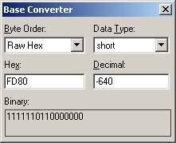

I have done this SEVERAL times with no results. Maybe one of you can figure out where I’m going wrong.

Here is a data file I have modified, and can verify the TX frequency at 902.0000 MHz.
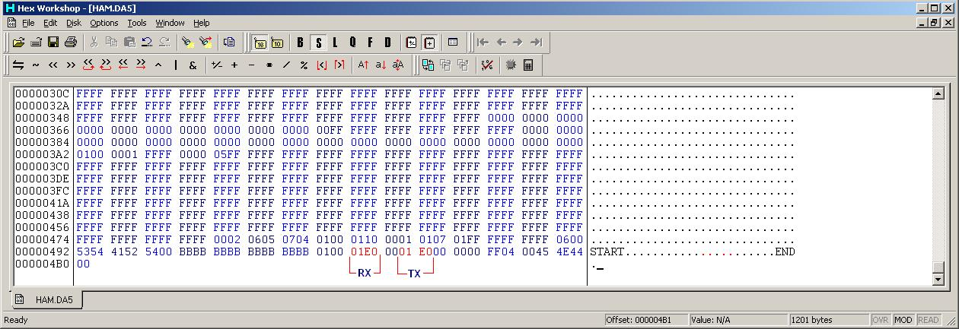

By using the “01E0” or FCC Ch. 480 entry in both RX and TX, you will see 902.000 MHz TX, and the built-in offset being 39 MHz, the RX would be 941.000 MHz. As of yet, I am unsure if the RX and TX entries could be individually modified for HAM use, i.e. directly program the TX for 902 and the RX for 927. However, I do believe that this radio should be capable of using the same type of “Scan” trick that some Kenwood’s do.

Data File Option Locations

If you refer to the “Common Data” entry page (first picture on this doc), here are some of the options with a blank file for comparison. Descriptions of what each comparison is, are to the right in each screenshot.

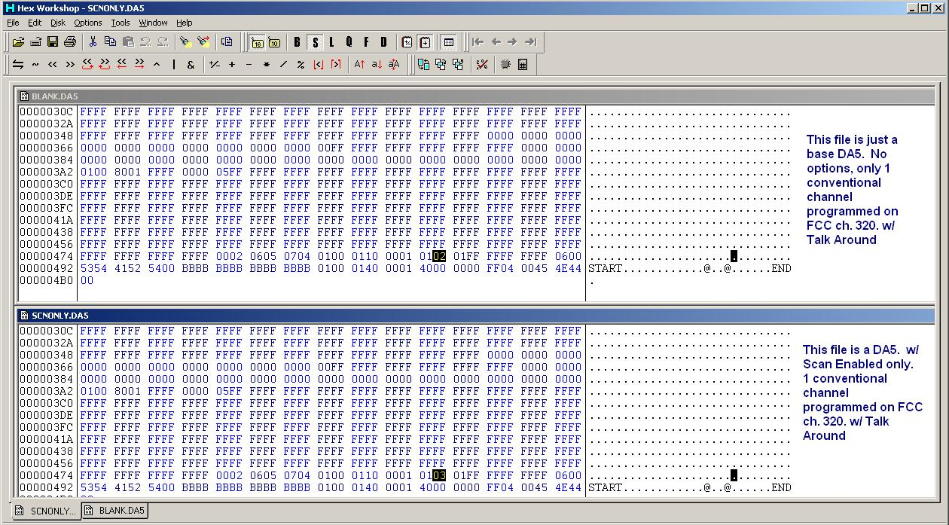

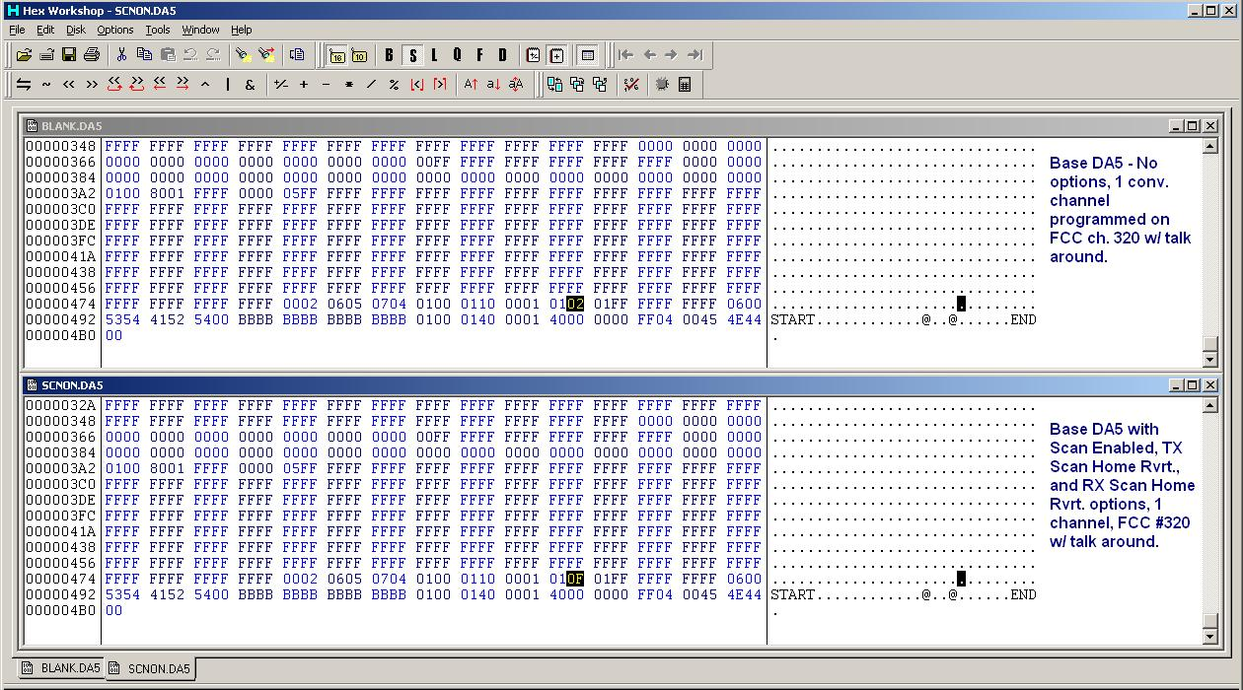

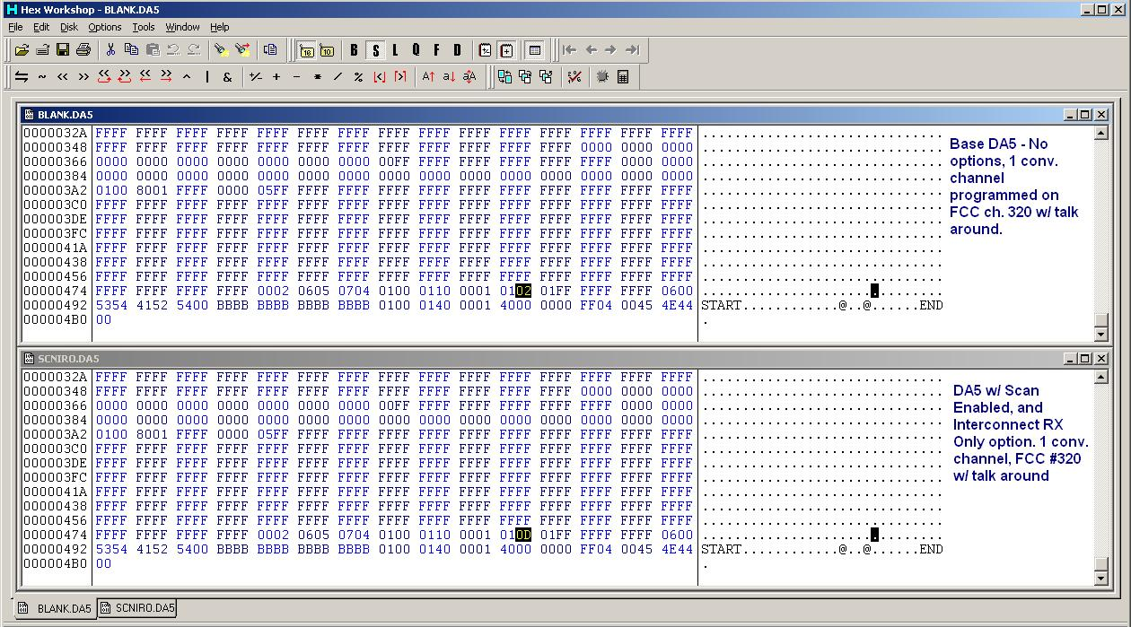

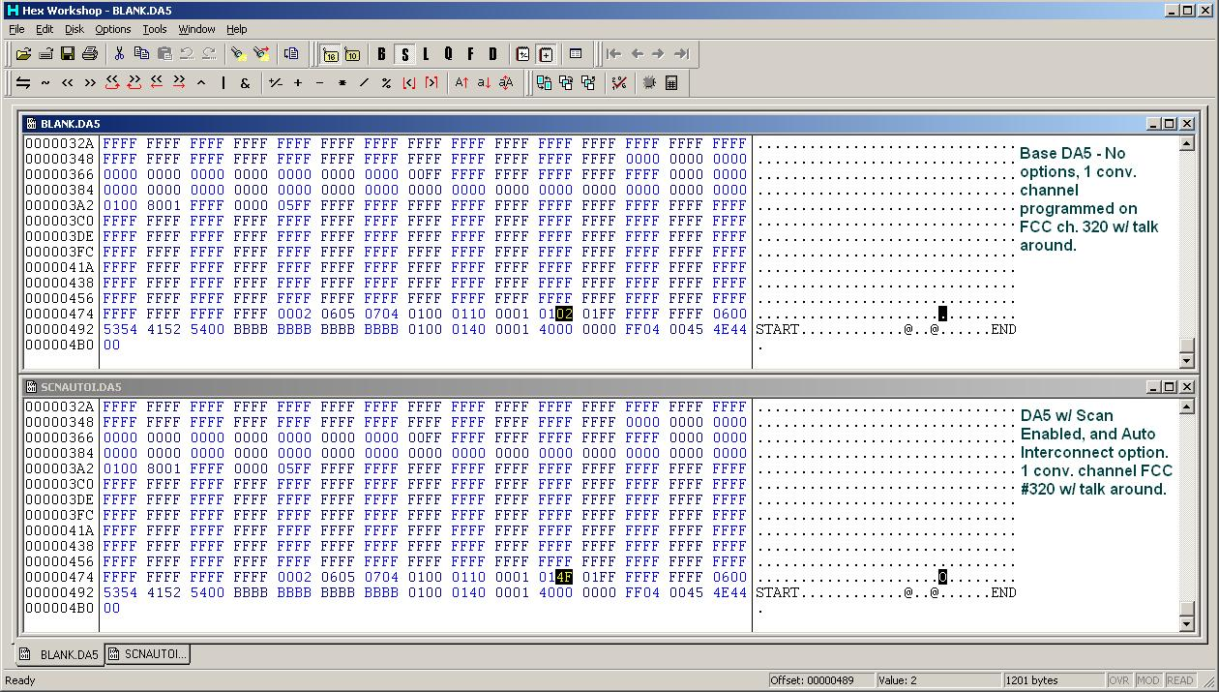

Well, that’s all I have for now. I may add or update at any time, so check the AR902MHZ Yahoo group for updates.

73

KG4JYE

