SYNTOR-X

Conversion

800 Mhz Trunking to 900 Mhz Amateur

Jim Gerwitz
AC7FN

11/21/03

SYNTOR-X is a trademark of Motorola Inc.
PREAMBLE
This document will be a combination of the information from reference sources with additions from my own experience, individuals, Motorola contributors and Web resources. In some cases, I will include information that I have not verified but I believe to be true. I will note those instances so that you may decide on your own if those options are important enough for you to try. If you try them and they are successful improvements, please let the rest of us know what you did.

This information is released for personal use only and may not be used in any way for commercial or business use.

DISCLAIMER
I have done 5 of these radios myself and I believe the enclosed procedure is accurate. However, I take no responsibility for the results that you obtain due to the fact that the condition of the radio; it’s component parts; your skills and abilities; your available equipment and numerous other factors including my memory make this conversion difficult and the results may vary. Any attempt to use this procedure is solely your responsibility.

ACKNOWLEDGMENTS and CREDITS
This primary contributor to this is Joe Paladino (SK) and Greg Raven KF5N. Without their inputs this collection would not be possible.

OVERVIEW
This procedure will attempt to describe the steps necessary to convert a Motorola Syntor-X 800 Mhz 35W Smartnet Trunking Radio PN T45VLJ5G11BK to a conventional 900 Mhz radio for use in the Amateur Radio bands. Most of these modifications may apply to the RF portions of a Syntor-9000, also made by Motorola. A converted radio will cover 902 to 928 Mhz. It is possible to replace the original microphones with Motorola Touch-Tones Mics for repeater and Autopatch access and control.

The Manual for a Syntor-X Smartnet Trunked radio is Motorola P/N 68P81066E80-B. I suggest you find one since I can’t possibly put all of the information it has into this document. You will need it to tune up the radio in the final step.

Here are the steps required to accomplish the modification.
STEP 1 – Test the ‘Trunked’ radio to make sure it works (good but not a ‘must do’)
STEP 2 – Replace the Personality Board
STEP 3 – Verification of a working conventional 800 Mhz radio (Must do!)
STEP 4 – Detailed RF MODIFICATIONS to achieve a 900 Mhz radio
STEP 5 – 900 Mhz Radio Test
STEP 6 --TRANSMITTER MODIFICATIONS
STEP 7 – Radio Alignment

REFERENCES
http://www.open.org/~blenderm/syntorx/indexx.html
http://home.xnet.com/~pakman/syntor/syntorx.htm
http://msuarc.egr.msu.edu/syntorx/
http://www.geocities.com/SiliconValley/5857/
http://www.piexx.com/SynXDoc/SyntorX.html
http://www.piexx.com/SynXFlash/SynXFlash1.html
http://www.repeater-builder.com/rbtip/syntorindex.html
http://www.brinkleyelectronics.com/prog/mot/synx/synx_eeprom.htm

CAUTION: This unit will transmit RF at frequencies and levels that can cause damage to the human body. Be careful to not expose yourself or others.

PROCEDURE
Before you start I recommend that you look at the referenced web sites so you know where they are and how the information in each is structured. You will visit the http://www.open.org/~blenderm/syntorx/indexx.html site frequently. My compliments to Mike for his comprehensive and exceptional site!

I am going to present a series of steps that I recommend that you follow to perform this conversion. Each step will refer you to an appendix at the back of this document that will provide details and other related information relevant to the specific step being performed.

I also recommend you read this entire procedure cover to cover before you decide to attempt it. It requires a lot of manual dexterity, ingenuity and out-right perseverance not to mention some sophisticated test equipment.

NOTE: It is of paramount importance that you have a radio with the Talk Around VCO. If you do not have this VCO this conversion will not work. The Motorola assembly number is HNL 1235A for the TA casting assembly. The TA VCO is specifically an HLN5356.

STEP 1 – Test the radio
I consider one of the most important things to do first, is to make sure the radio you have is working, both Tx and Rx, but you can skip this if you want. Frankly, it is doubtful that you will have a Trunking EEprom that you can use since most of the radio shops pull them when they decommission the radios. If you do not have a properly programmed Eprom module for your Trunked radio or if you choose to skip this step, go to Step 2, Replacement of the Personality Board.

Assuming that you have started with the Trunking radio version and you have a Trunking EEprom, connect the Trunking Control Head, the mic, speaker, cable and radio together and connect to a ‘stiff’ 12 v supply. A 12 v battery works fine for this. You can expect the 35 watt radio to typically draw 10 to 20 amps.

CAUTION: Whenever connecting or disconnecting the main connector to the radio, make sure the 12 v is off or disconnected! Damage to the radio can result if this precaution is not taken.

See Appendix A for specific details of the Trunking radio test, or refer to your manual.
There are a couple of circuit tabs on the Personality Board inside the radio that puts the Trunking radio into a test mode. If you can make the radio go into the test mode and you can make it perform the tests, this is a good indication the radio is alive. I also recommend that you look at the main connector inside the radio and check for jumpers and wiring made right at the plug.
You won’t get much out of this test since you won’t have any control channel. Don’t be afraid to skip this test.
STEP 2 – Replace the Personality Board and remove Trunking Radio components
In order to make a Trunking Syntor-X into a conventional radio, we have to remove all Circuit boards associated with Trunking. Some will be replaced with conventional assemblies scrounged from other radios.

Place the radio with the handle toward you and the heavy cast lid down. Use a screwdriver to remove the 4 screws from the light metal cover. The common circuits board is the one on the right with hinges, resting between the front of the radio and the metal ‘casting’, which houses the RF amp; the VCO and the buffer assembly as well as the filter assemblies. Any boards to the left that are mounted on top with solder joints facing up need to be removed. My radio had a Trunked Filter board, TRN4274B in the upper left position and a PL/DPL HLN5357A board in the lower left. Remove any boards on the left side that are mounted with the solder joints pointing up and the components pointing down. They will not be used.

Turn the radio over and remove the heavy cast cover. The PWB board on the right is the personality board. You need to remove it and replace it with a conventional PWB PN HLN4670 A, B or C revision. You can’t convert a Trunking Personality Board to a conventional Personality Board so you will need to find one of the above somewhere in another radio. These are usually stripped out of working VHF or UHF radios (making them useless),

You will need to visit Mike’s excellent site at http://www.open.org/~blenderm/syntorx/indexx.html to make sure all your jumpers on the Personality Board are set properly. Generally if you remove the Personality Board from a working VHF or UHF radio, you won’t have to make any changes to the jumpers.

(There is a way to make a VHF or UHF Syntor-X with its Personality Board removed, useful again. Visit the Piexx website at www.piexx.com where you can buy the Piexx replacement for the Personality Board. I recommend you visit their website and view their excellent offering. Using the Personality Board out of a good VHF or UHF Syntor-X for this conversion and putting in the Piexx replacement in the other unit will give you two excellent radios. I don’t believe that their system works on 900 Mhz but it is a great solution for low band, VHF or UHF radios if you scavenged a personality board out of them for use in this conversion).

STEP 3 – Verification of a working conventional 800 Mhz radio.
Verifying that you have a working 800 Mhz radio is paramount and is a must do step!

Once you have replaced the Personality Board you need to test the radio but before you do, there are two issues to deal with here.

Issue 1:
You need a conventional radio cable, Control Head, speaker and microphone to do this test or you need to build your own. I will include a schematic and a description of a home built Control Head in Appendix B. I assume you got a “Trunking” type clamshell control head with your radio, or possibly a set of ‘Systems 90’s’ accessories. Either way, the Trunking accessories are useless, as is the cable, except for the microphone and the speaker. You can use the main radio connector and cable to attach your home made Control Head to the radio.
I suggest you find someone that has a setup for a conventional Syntor-X and you borrow it for this test, that way you are dealing with less unknowns.

Issue 2:
The other issue that needs to be dealt with here is the EEprom Module. Dealing with the EEprom programming is complex. Take a look at the http://www.open.org/~blenderm/syntorx/indexx.html website and look under “Programming”. This will help you see what you are up against.

Once you have looked at the situation, take a look at Appendix C and decide how you are going to attack programming your EEprom module. Your options are listed there. It is easiest to find someone that will do it for you. If you run out of options contact me and I might be able to help. Also, if you can’t find the HLN1125 module on eBay or other places like on line swap meets, you can make your own or modify the non-programmable version. Contact me for details.

Here are some related tips: When you locate the Personality Board that you intend to buy or scrounge, you need to make sure you get an EEprom module to go with it. I recommend the HLN1125 with the orange stripe.

To test the radio here in STEP 3, I recommend a simplex test frequency of 865.000 in mode 1 of the EEprom module. This will allow you to verify operation of the radio.

You must have a programmed EEprom module to perform this test.

Once you have a changed the Personality Board and plugged in a programmed EEprom module, verify operation of the radio including power output (remember this will be in the 800 Mhz band), the deviation, the receive sensitivity, and if possible, view the Tx output signal with a spectrum analyzer to confirm that it is clean and free of spurs and other junk.

Verification of proper operation is very important. If the radio doesn’t work correctly here, it won’t work correctly at 900 Mhz!

Once you are confident that the radio is working OK, set the cable and accessories aside for use after you have made the 900 Mhz modifications below. You will need them when you have a modified 900 Mhz radio to test.

STEP 4 – Detailed RF MODIFICATIONS (This part applies to the X9000)
There are several modifications to be made:
a) The Injection Filter and Pre-selector coils in the casting have to be modified and have a portion of a turn removed, then retuned, see Appendix D;
b) The Buffer/Doubler assembly has to have a cap changed and two coils modified/replaced . See Appendix E;
c) The VCO has to have a chip cap changed and some circuitry added, see Appendix F;
d) The RF amp has to have one chip cap changed, one chip cap added and a filter bypassed, see Appendix G
e) The Transmitter and harmonic filter inside the radio chassis has to be modified, see Appendix I.

We will proceed through these one at a time and each has an appendix with information.

Coil modifications: (Appendix D)
NOTE: I understand that replacing the coil slugs with Aluminum or Brass has been used as a technique so that the coils do not need to be modified. I have not tried it but based on personal experience on other projects, there is no reason that it shouldn’t work. Now is the time if you want to do so. If you change out all the slugs, skip all the coil modification details and go to the casting tuning instructions in Appendix D. (I would recommend brass screws, not aluminum).
I have not had to modify the two RF Preamplifier coils. Retuning the RF Amp with the existing slugs has worked just fine so don’t attempt to change the slugs in these two coils if you elect to use brass or aluminum slugs.

Coil Modification Details:
You need a good 200 watt iron and a sharp pair of side cutters for this. I usually do this being very careful to put the same coil back into the same position I remove it from.
- Remove the casting from the radio.
- Unsolder and pry off the cover plates from the back of the casting which are used to cover the back of the coils for ONLY the 3 and 6 coils sections that are in one single line. The three coil section is the Injection filter and the 6 coil filter is the Pre-selector filter.

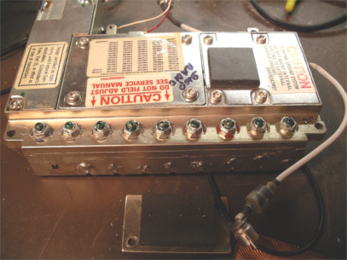

Picture of the casting assembly and coil areas.

The three coils on the right in this view are the Injection filter. The 6 on the left are the Pre-selector coils.

- Use the 200 w iron to unsolder the coil wire from the slot in the side of the casting and pop the coil out of the hole by pushing on the plastic part from the front while the solder is soft, (the large coil wire is the only rigid attachment). Use a little solder wick to clean up the slot so it will be easy to put it back. Doing all this will take some development of your technique. Cut 3/16 of a turn off the coil on the top end. Use the side cutters in a direction so that the end is flat and clean, BEING CAREFUL TO DO EVERY COIL THE SAME. Replace the coil making sure it is fully seated and re-solder the heavy lead in the slot. Two of the coils have taps soldered to them. As I recall I didn’t want to move the tap at all so I unsoldered the other end and removed the tap with the coil, then re-soldered them when I put the coil back. Once all of the coils are done, perform the coil tuning procedure per Appendix D before replacing the cover plates and tack-soldering them as they were.
You only need to tune the 3 injection filter coils and the 6 Pre-selector coils. The two RF Amp coils are left alone.
Make sure each cavity is clean and free of any conductive material (solder flecks) before you put the coils back.
- For tune-up, see appendix D .
  - The Injection filter section should be tuned to cover 848.1 to 874.1 Mhz (Three coil section)
  - The Pre-selector section should be tuned for 902 to 928 (Six coil section)
  - The RF Amp coils are tuned per Appendix G.

Buffer/Doubler Modification: (Use ESD precautions here!!!)
See Appendix E for the details of the one chip cap and two coils that have to be changed. After changing the cap, I removed the existing coils and carefully removed existing turns to get them to size. I then put them back. I found it was easier to reconfigure the existing coils than make new ones. Replace the Buffer/Doubler cover when done.

VCO Modification: (USE ESD precautions here!!!)
See Appendix F for details. You will need to remove C659 and replace it with a 7.5pf chip cap.

The most difficult part of the VCO mod is adding the circuitry to shorten the tuned VCO transmission line. You can see from Appendix F and the diagram how this is done.

RF Amplifier modifications: (USE ESD precautions here!!!)
See Appendix G for details.
Step (1) Replace chip cap C102 with a 27 pf cap.
Step (2) Add a 27 pf chip cap as shown. I scraped the insulation from over the circuitry and pre-tinned the end locations for the cap. Use as little heat as possible to prevent leaching the conductive material out of the substrate circuitry.
Step (3), Use a small piece of semi-rigid cable to bypass the filter on the back of the RF amp board and cut the circuitry at the input and output. This bypasses the filter made up of L105, L106 C111, and C112. You can see where I did it in the picture. Step (4), Clean up any flux left using alcohol.

It has been reported to me that one person uses a MAR-8 MMIC to form an amplifier to bridge the filter but I have not tried it. Since voltage is available in the RF amplifier housing it would be easy to do and select a resistor to set the proper gain of the MAR-8. Details are in the Appendix G.

Step (5), Once all modifications have been made to the circuits in the casting, replace the casting into the radio and reconnect all the RCA jacks, reassemble the boards and tighten all the screws. Perform the RF Amplifier tune-up as explained in Appendix D.

Put the 900 Mhz test EEprom into the EEprom module and plug the EEprom module onto the personality board.

If everything has been done correctly, you should have a working 900 Mhz radio. The only things left to do are to make sure the VCO loop locks across the band, final tune of the RF Amp and then fix the transmitter.

STEP 5 – 900 Mhz Radio Test. (This also applies to the 9000)
Connect the radio to the cable with all the accessories. Unless you are using a Communications Test Set, leave the mike off so you can’t accidentally transmit. Set the radio to mode 1 (902 Mhz) and inject a 4 or 5 microvolt signal into the antenna port with a tone on it. With any luck you should hear the signal just fine. Using the mode control, work up through all of the positions on your control head for both Tx and Rx, all of them should work. If not, record which frequencies/modes do not work.
If you have no audio even with the Squelch open, check the red LED PLL lock indicator on the bottom side of the radio toward the front of the radio. It will be on if the loop is out of lock. Improper programming of the EEprom is one cause for the VCO to fail to lock which will also lock out any audio. If you get audio with the squelch open more than likely the EEprom is programmed ok. Since there is a correspondence between the frequency in the EEprom and the mode that is set on the Control Head, make sure the correct mode is set and the generator is on the corresponding frequency for the mode selected.

Let’s assume for the moment that the 902.0000 frequency doesn’t lock but all the other modes do. To fix it we are going to have to change the amount of tuning pads that are wired into the circuit on the VCO board. (See the picture in Appendix F. Look for the railroad tracks.)
Here are some general facts to consider: The VCO loop voltage goes from down around 2 volts for the low VCO frequency to maybe 9 volts for the maximum frequency. If the 902 frequency won’t lock, then the loop voltage is unable to go low enough. That means we need to add more ‘squares’ (more capacitance) into the circuit so that the added capacitance will lower the oscillator frequency and the loop control voltage won’t need to be so low.
Shut off the unit, and using good ESD practices, remove the VCO cover and add one square into the circuit by bridging it with some fine wire). Replace the VCO lid and power up. Check mode 1 to make sure the 902 frequency locks. Perform this process until all modes from 902 through 928 Mhz lock properly.

At this point you should have a working receiver. If not, you need to go back through and look for solder shorts, open coil joints etc. If you have done this right, I can guarantee that it should be working.

STEP 6 -TRANSMITTER MODIFICATIONS: (Applies to X9000 also)

Now attach the Mic. and a proper load to the TX port and check all the modes for proper Tx. Output power will be down in the 1 or 2 watt range. Just check every mode to make sure the VCO locks.

Now modify the transmitter and the harmonic filter per the directions in Appendix H.

STEP 7 – Radio Alignment
You should now have a functioning 900 Mhz Syntor-X radio. Its time to finalize your Control Head if you built your own and get things buttoned up.
Before you close up the unit, I strongly recommend that you go through and do an alignment on the radio as shown in the manual. This will make sure you are on frequency and that the deviation is correct. Make sure you check compensation, Deviation and Frequency as well as Tx and Rx operation across the band. Also check the output spectrum for spurs and harmonics. This is a must and this step should not be skipped. No self respecting HAM should try and put this unit on the air without a good alignment.

My guess is that if you are unfamiliar with the Syntor-X, this procedure could take you a week of evenings and maybe more. However you will end up with a radio that is dependable and solid as a rock!

I will try and answer questions at ac7fn@earthlink.net.

Good luck!

Jim
AC7FN
Appendix A. Trunking Radio Test

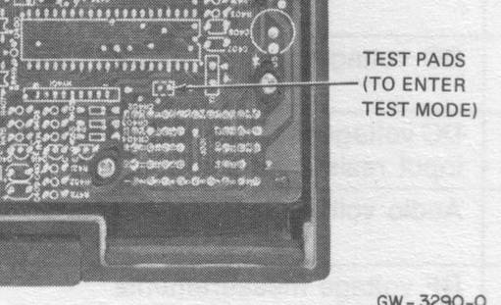

Here is a picture of the right front corner of the TRUNKING version of the personality Board. The two pads that you short together momentarily are shown. The main radio connector is in the lower right hand corner of this picture but the main cable is not attached.

Here is the test procedure right from Motorola’s manual.
    - Channel Selection
- Apply power to the radio under test. Momentarily short the test pads together. A single 450 Hz beep sounds from the speaker to indicate operation on F1, after which the receiver unmutes.
- Step the radio to the next channel by tapping the microphone PTT button (this is achieved by pressing the PTT button and releasing it within 200 milliseconds). Two beeps will sound to indicate F2, after which the receiver unmutes. This procedure can be repeated to step the receiver from F1 through F4 with the number of beeps indication the F number.

2.2.4 Transmitter Alignment
      - Transmit Modes
Three transmit modes are used for various transmitter checks and adjustments:
- Silent carrier
- Subaudible connect tone plus voice-low speed mode
- High-speed ACK tone-high speed mode
      - Silent Carrier
On a given channel, when the microphone PTT button is pressed and held, the microprocessor keys the PA without data modulation, and the MIC audio is enabled. In this mode, the transmitter frequency, hum and noise, and voice deviation can be checked and adjusted. When then the PTT button is released , the PA is dekeyed, and the receiver unmutes.
      - Subaudible Connect Tone Plus Voice-Low Speed Mode
If the microphone PTT button is pressed held again, the PA is keyed with a 105.88 Hz subaudible tone modulation and a pulsed 180 Hz tone sounds. This tone is known as the talk prohibit. This step is used to adjust the maximum voice plus subaudible tone deviation.
- +/-4 Khz deviation for voice
- +/-1 Khz deviation for subaudible connect tone
- +/-5 Khz deviation total
When the PTT button is released, the pa dekeys and the receiver unmutes.

APPENDIX B. HOME BREW CONTROL HEAD

13

17

24

25

12

16

23

29

The 'Mode’ lines determine the mode or frequency that is selected as well as how the selection is performed. See the tables on the following page for details. If you have an 8 position rotary switch and you don’t need more than 8 frequencies, you can use the simple approach.

If you want up to 64 frequencies, use the second table. I suggest BCD thumbwheel switches with decimal numbers so that the switches read 1 through 64 and the binary outputs switch all 6 binary mode lines. You can ground the Mode 7 and mode 8 lines at the connector.

I used a MAXAR 80 Microphone and connector since they are very sturdy and have a screw-on attachment mechanism. Use very heavy wire for the main supply and ground wires attached to “A” and “B” if your connector doesn’t have any. You can order the connector body, contacts, cover and thumb-screw knob from Motorola if you can’t salvage one from an old cable. Remember Trunking cables are useless so I suggest you use the connector from one.

Mode Select:
MODE SELECT - 8 MODE CLAMSHELL
M1 | M2 | M3 | M4 | M5 | M6 | M7 | M8 | Description
0 | 1 | 1 | 1 | 1 | 1 | 1 | 1 | Select Mode 1
1 | 0 | 1 | 1 | 1 | 1 | 1 | 1 | Select Mode 2
1 | 1 | 0 | 1 | 1 | 1 | 1 | 1 | Select Mode 3
1 | 1 | 1 | 0 | 1 | 1 | 1 | 1 | Select Mode 4
1 | 1 | 1 | 1 | 0 | 1 | 1 | 1 | Select Mode 5
1 | 1 | 1 | 1 | 1 | 0 | 1 | 1 | Select Mode 6
1 | 1 | 1 | 1 | 1 | 1 | 0 | 1 | Select Mode 7
1 | 1 | 1 | 1 | 1 | 1 | 1 | 0 | Select Mode 8
- When mode lines M7 and M8 are not both pulled to ground, the radio uses each individual mode line (M1-M8) to select one of 8 modes.
MODE SELECT
M1 | M2 | M3 | M4 | M5 | M6 | M7 | M8 | Description
0 | 0 | 0 | 0 | 0 | 0 | 0 | 0 | Select Mode 1
1 | 0 | 0 | 0 | 0 | 0 | 0 | 0 | Select Mode 2
0 | 1 | 0 | 0 | 0 | 0 | 0 | 0 | Select Mode 3
.... | .... | .... | .... | .... | 0 | 0 | 0 | ....
1 | 0 | 1 | 1 | 1 | 0 | 0 | 0 | Select Mode 30
0 | 1 | 1 | 1 | 1 | 0 | 0 | 0 | Select Mode 31
1 | 1 | 1 | 1 | 1 | 0 | 0 | 0 | Select Mode 32
0 | 0 | 0 | 0 | 0 | 1 | 0 | 0 | Select Mode 33
1 | 0 | 0 | 0 | 0 | 1 | 0 | 0 | Select Mode 34
0 | 1 | 0 | 0 | 0 | 1 | 0 | 0 | Select Mode 35
.... | .... | .... | .... | .... | 1 | 0 | 0 | ....
1 | 0 | 1 | 1 | 1 | 1 | 0 | 0 | Select Mode 62
0 | 1 | 1 | 1 | 1 | 1 | 0 | 0 | Select Mode 63
1 | 1 | 1 | 1 | 1 | 1 | 0 | 0 | Select Mode 64

APPENDIX C. SYNTOR-X EEprom Programming

Before you do your programming, and possibly before you undertake this entire project, I recommend that you buy three 28C16 EEprom’s from Jameco and determine how you will program them, (more on this below). –15’s work just fine.

Use one EEprom for the 800 Mhz test frequency. I suggest a frequency of 865.000 Mhz but any frequency up to about 890 will work.

Use the second EEprom and put the following simplex frequencies into it starting in mode 1 working up: 902.0000, 906.0000, 910.0000, 920.0000, 924.0000, 928.0000. I picked these because a 6 mode clamshell Control Head is common. Since the middle of the band is useless, this frequency spread works well. The actual frequencies are really up to you. Pick a range of frequencies that match the number of modes available in your Control Head. You will need this EEprom when we get ready to test the 900 Mhz operation later. (Please note that your radio cable has to support and be wired to handle the method of frequency selection, see Appendix B above).

If you have a 4 mode Control Head, use 902.000, 904.000, 926.000 and 928.000 if you plan on using the 25 Mhz splits as most are doing. This 4 mode test chip will allow most of the testing that you need to be completed successfully. It will also give you the capability to ensure that the VCO PLL locks across the full 902 to 928 Mhz band.

First let’s address the frequency selection issues. Syntor-X’s have a number of ‘mode’ or frequency selection lines. The radio can either have a simple rotary switch that selects a single mode line and therefore selects the particular frequency programmed into the EEprom for that mode, (max is 8 modes in this configuration). The other option is to have a BCD switch with 5 bits and the SW can select 32 modes. To use this method you have to have several of the higher mode lines grounded. You will have to visit Mike Blenderm’s site http://www.open.org/~blenderm/syntorx/modelsx.html#top_mod and read the details and make sure your Control Head and radio cable are setup properly.

Here are you programming options.
- Purchase the programming service from a Motorola shop
- Find a friend or someone to program them for you, by using the web and the 902 reflector.
- Search the web for the 3 or 4 programs that are out there that will program the EEproms for you, (See KB8ZQZ’s page at http://msuarc.eng.msu.edu/syntorx/ ).
- Build a hex image by using the info on the web. (not recommended)
- Contact me and I can do it for a modest fee at: ac7fn@earthlink.net

There are a series of options that you will need to decide at programming time, including scanning options. You will have to work with your programmer to determine what they are and what meets your needs. They are too numerous to detail here.

Getting a Syntor-X working and getting all the frequency selection connections set properly is a real pain but if you read Mike’s page you will be able to figure it out and make it work. This is the advantage of getting some one you know to do it for you.

Use the third EEprom and have the frequencies you want programmed into it. I suggest you have all three chips programmed at the same time. Life will be a lot simpler that way.

APPENDIX D. RF FILTER TUNE UP

FILTER TUNEUP
There Injection filter and the Pre-selector filter assemblies must be aligned after the 3/16 of a turn is clipped off and the coils replaced.

You will need a couple of special cables and a Communications Test set with a tracking generator (or equivalent) in order to tune the filters.

Make at least two test cables using two pieces of RG-174 coax with BNC connectors. The RG-174 should be kept as short as possible after the BNC connector, maybe an inch or so. Strip back the outside sheath and fish the center conductor out through the braid. Leave a ¼ inch of insulated center conductor and then strip off the center insulation for the last 1/8th in. You will use these test cables by soldering the center conductor to test points and jamming the braid under screw-down lids to make ground connections. Very short lengths are a must here. You will need a 3 or 6 db attenuator for each cable for the alignment.

Before you start, remove the mixer cover from the casting assembly by removing the two screws. It is the small rectangular cover on the casting on the opposite side from the tuning screws. You will see two small leads on the same side coming through slots in the housing from the Injection filter assembly and the Pre-selector assembly. These are the two locations that you will use in the alignment in the next paragraphs.

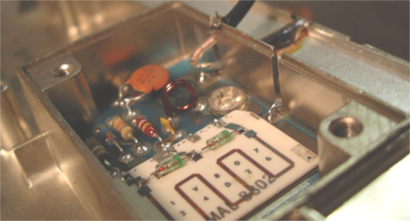

Picture of test cable setup and Mixer Assembly

You can see the mixer assembly with the two slots where the leads from the coil assemblies come in. The far slot has the RG-174 coax placed in it with the center conductor soldered to the lead from the Pre-selector output. The braid can be seen at the top of the slot ready for the lid to be placed on it and screwed down, (see below).

Here is my technique:
It really doesn’t matter which filter is done first so lets tackle the 3 coil Injection filter. Remember the I.F. frequency of this radio is 53.9 Mhz with low side injection so the injection filter has to be tuned from (902-53.9 =) 848.1 Mhz on the low end to (928-53.9 =) 874.1 Mhz on the high end. Remove the Mixer cover using good ESD practices and unsolder the small feed that comes through the mixer wall from the last injection filter coil. After you unsolder the coil lead from the pad on the mixer, bend it up slightly, slide the small coax into the slot and tack solder the end of the test cable to the wire from the injection filter coil. Carefully place the braid of the test cable in the area where the mixer lid will sit, place the lid on and screw down the two mixer screws. This technique uses the braid and the lid to form a good ground. Remember to keep all leads as short as possible.

On the input end, remove the small coil cover over the RCA jack and unsolder the wire from the center of the jack. Using the second test cable, solder the center conductor to the wire removed from the RCA jack. Jam the braid under the lip of the lid and press the small lid back down. Using the attenuators on each cable to improve the match to 50 ohms, align the Injection filter for the above frequency range and try for as flat as response as possible. Once you have achieved a good response, reverse the procedure to remove the test cables and put the injection filter back as you found it. You will need to move the test cable in the mixer to the other mixer input.

The 6 pole Pre-selector filter is tuned using the same techniques and test cables with attenuators. I tack soldered one cable right onto the feed point at the back of the RF Amplifier after I cut the feed as required to do the RF Amp modifications. Remember to tune the Pre-selector filter for a flat response from 902 to 928 per Appendix G.

If you have done a good job with the coil modifications, you will find that the coils will all be at about the same length after tuning. It isn’t important that they but it will be a good indication of how consistent you were in modifying the coils.

Here is what I do for the RF Amp coils.
After I have the Injection and Pre-selector filter tuned on the bench, I modify the RF Amp per instructions in Appendix G. Next I put the casting assembly back into the chassis. Based on experience, I recommend that the two pole RF Amplifier filter, be adjusted in the chassis with power applied.

Just to clarify, the input to the RF amplifier is an RCA jack. Remove the cable which is normally plugged into the RCA jack, and replace it with a test cable that has an RCA plug and a short run to a BNC connector. Place a 3 or 6 db attenuator there and then use a longer cable from the attenuator to the tracking generator. The attenuator is used to help force a better impedance match to the RF Amplifier input. For the output of the RF Amplifier, I use one of the short BNC test cables that was used for the filter tune-up, to pick up the output of the RF Amp back at the end of the by-pass that I installed. I use the RF Amplifier lid to capture the braid as before and I tune the two pole RF filter for best gain and flat response from 902 to 928 WITH POWER ON. The tuning is very broad and requires little tuning of the coils but having the amplifier operating gives much better results. REMEMBER TO KEEP THE INPUT SIGNAL AS LOW AS POSSIBLE. Once the alignment is complete I solder the output of the RF Amp to the input of the Pre-selector filter and close everything up.

APPENDIX E. Buffer/Doubler Modifications

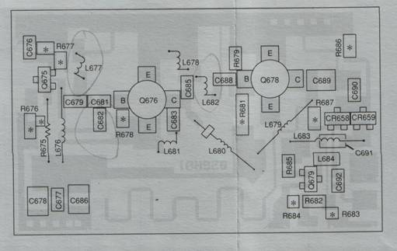
Buffer/Doubler circuit layout.

Modifications for the Buffer/Doubler:
- Replace capacitor C682 with a 2.2 pf chip cap. (It should be 3.3 pf before the mod).
- Change L677 to a 1/8 in dia. 2 turn coil of #28 enameled wire.
- Change L682 to a 4 turn 1/8th in dia. air wound coil of #24 enameled wire.

I found it easier to take the existing coils off, one at a time and shorten them to the required number of turns and then re-solder them onto the substrate.

If you just remove turns from the existing coils like I do, you will notice that the coils are not 1/8th in diameter. I am sure that making them the correct diameter makes the inductance different but the system works fine by removing turns. If you wind new coils and find out that it improves output power or something, please let me know. Since I have not tried it, I would like to know the results.

APPENDIX F. VCO Modifications
VCO Modifications:
There are two mods to the VCO.
- Change C659 from a 10 pf cap to a 7.5 pf cap.
- Shorten the VCO Transmission line by soldering the flat piece of shim-stock as shown and described below.

See the next page for a picture of the added metal piece that is used to shorten the VCO tuned line. The shim-stock is cut in the shape of a fat ‘L’ and is soldered to the track of the substrate. Notice that the top of the shim-stock runs right along the edge of the triangular ground plane in the upper corner of the VCO and is soldered to it. The right edge isn’t critical as long as it is soldered tightly to the ground plane on the right edge of the substrate. The bottom edge is cut so that you don’t have to zigzag around capacitor C673. I made my parts so that the left side starts about in the middle of C673 and runs up until it hits the side of the tuned line, then goes left until it is .040 away from the line. I have outlined the “L” in solid lines and tried to show the conductive circuitry on the VCO substrate with dashed lines. There is an actual picture on the next page of the appendix.

Here is how I did it. First I found a small piece of brass shim-stock about .005 thick. (This should be available at a hobby store or your auto parts store. Thickness isn’t too important. It is primarily for handling convenience.) I then polished both sides with Scotch-Bright from the grocery store so I could tin it. I used the 200 W iron and solder to coat both sides and then I removed most of the excess solder and cleaned off all flux residue with alcohol. I cut the piece to size being careful to maintain the desired spacing. (Make sure the piece is flat when you finish tinning it). I then abraded the circuit area on the substrate in the casting with a fiberglass eraser and cleaned it with alcohol. I then pre-tinned the area with the 200 w iron and some solder.
Next, I placed the pre-cut piece exactly where I wanted it and held it down with a toothpick. I used the soldering iron to press the piece down and reflow the solder in 3 or 4 separate locations. Once tacked in place I carefully worked the iron over the entire area to attach it completely so that there are no gaps underneath.
Clean any flux off the VCO assembly with alcohol including the areas around the chip caps that have been changed.
Put just a very tiny amount of oil on the four screws before you replace the VCO lid. You will most likely take the lid on and off several times later on and the oil will prevent the threads from galling. It is best to have things covered up while other modifications are going on.

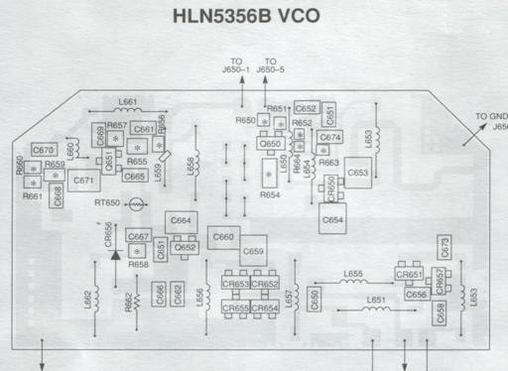
NOT TO SCALE
C659

Layout of the VCO substrate. Change Capacitor C659 to 7.5 pf.

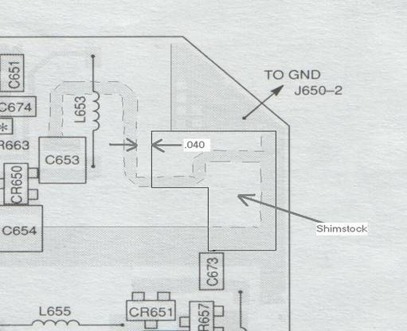

Here is a color picture of the modified VCO. The solder mess in the upper right corner is the added piece of Shim-stock.

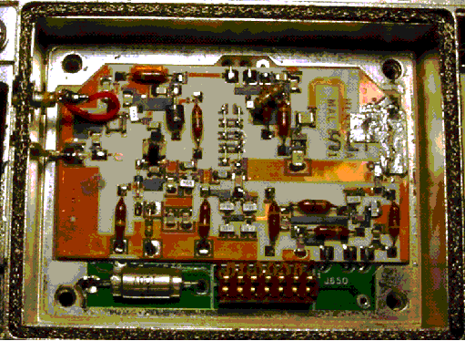

Note the railroad track capacitors in the center running vertically. This is the area that you will have to work in to get the VCO to tune properly.

Appendix G. RF Amplifier Modifications

RF Amplifier modifications
- Remove C102 and add a new 27pf cap 90 degrees to where C102 was. (See diagram below)
- Add a 27pf capacitor from the node between C105 and C106 to the corner of the transmission line from the collector of Q101 as shown.
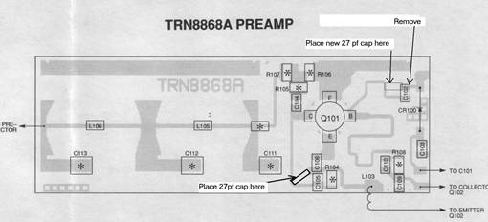
3) Bypass the low-pass filter by cutting the input and output transmission lines and routing a small 50 ohm coaxial or semi-rigid line around it as shown.
Filter bypass

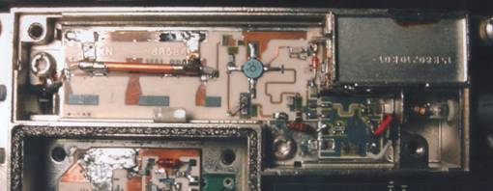

It has been reported to me that a MAR-8 MMIC can be used to add RF gain in place of the bypass of the filter as shown above. Here is the info I was given but I have not tried it: Use a MAR-8 MMIC. Gain is close to 20 db with a 3.5 db noise figure. Use .001 chip caps to the input and output. Use a 51 ohm decoupling resistor from the MAR-8 to another resistor tied to either 9 or 12 volts. There should be a .001 mf cap from the junction of the two resistors to ground. Use the value of this resistor to set the gain and bias current. Some expermentation will be required.

APPENDIX H TRANSMITTER MODIFICATIONS

Transmitter Modifications:

There are two modifications that you must make in order to get more than a few watts out of the radio.

1). First find the yellow wire that runs from the common circuits board to the back of the chassis under the PA and attaches to one of the feed-through cpacitors. Cut the yellow wire and insulate both ends. You will get about 20 watts out at 902 and 12 to 15 out at 928.

This change allows the TX to run at maximum smoke. Some units will put out 18 to 20 watts, some will put out 60 watts. It’s the luck of the draw. Since 800 Mhz Trunking radios are so cheap, this is the most cost effective solution. I have one unit in my truck on a 900 Mhz cell antenna and one unit on a home built coaxial antenna under my bench and neither has had any problem operating this way for over 2 years. I don’t think the power adjust pot will have any effect after you cut the yellow wire but I really didn’t check it.

2). You will need to modify the Harmonic Filter that is located in the recessed portion of the housing.
You have 2 options: 1) Isolate the center conductor path on the substrate or, 2) unsolder the center conductors of the two coax at each end of the filter and place a short piece of coax in between. Do whatever is easier for you. If you place a small piece of coax or semi-rigid cable from the two connections, make sure you solder the braid to ground on each end and keep all connections less than ¼ inch.. This effectively bypasses the filter. Check for shorts and replace the lid over the filter.

TIPS: I used a Dremel tool to cut the filter track, (which is hard to do). I have lifted the center conductor at both ends and used coax and in some cases I used some semi-rigid cable. The semi-rigid cable is the easiest solution but you may not have access to it.

Ideally, what should be done if one had the equipment, would be to tune this filter so that it had a cut off above 928 Mhz and looked like 50 ohms across 902-928.

If you figure out an easy way that everyone can use to tune this filter, please let me know.

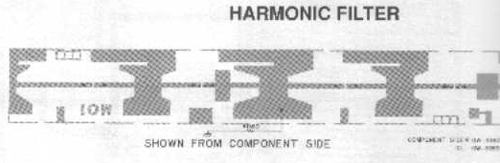

Here is some unverified information that I have:
There are some potential drop-in replacements for the PA modules. They are numbered TLF6432A, TLF6442A and TLF6452A. These are rumored to be ‘up-ranged’ for paging and are said to be the same devices and mechanics as Syntor-X second source lineup. Also it is rumored that the MRF-840 replaces the M9875 and the MRF-842 replaces the M9876.

